RESOLUTION NO.__________

RE: CERTIFICATE OF APPROPRIATENESS UNDER THE
PROVISIONS OF THE ACT OF THE PENNSYLVANIA
LEGISLATURE 1961, JUNE 13, P.L. 282 (53
SECTION 8004) AND BETHLEHEM ORDINANCE NO.
3952 AS AMENDED.

WHEREAS, it is proposed to install new signage reflecting the new business logo at 12 West Fourth Street.

NOW, THEREFORE, BE IT RESOLVED by the Council of the City of Bethlehem that a Certificate of Appropriateness is hereby granted for the proposal.

Sponsored by: (s)

(s)

ADOPTED BY COUNCIL THIS DAY OF

(s)
President of Council

ATTEST:

(s)
City Clerk

HISTORIC CONSERVATION COMMISSION

CASE #641 -- It is proposed to install new signage reflecting the new business logo at 12 West Fourth Street.
OWNER/APPLICANT: Linda Villani/Alison Leaver

The Commission upon motion by Mr. Lousch and seconded by Mr. Evans adopted the proposal that City Council issue a Certificate of Appropriateness for the proposed work described herein:

- The proposal to install new signage reflecting the new business logo at 12 West Fourth Street was presented by Alison Leaver.
- The proposed sign is a single-faced Medium Density Overlay (MDO) panel measuring 24” high x 80” wide with applied laminated digital print of the new business logo artwork: “HAIR BY ESKANDALO”. The script is stylized capital letters, with underlined company name that is significantly larger than the remaining text that terminates in a graphic interpretation of open shears; beige lettering to match the paint color of the existing building trim is outlined in black. The signage background is deep red and the sign has an overall thin black border.
- The proposed signage is designed to hang approximately 18 inches away from the front façade of the business location by use of two forged steel mounting brackets attached to the underside of the existing cornice as well as to the vertical framing members of the enclosed front porch.
- The motion for the proposed work was unanimously approved.

JBL: jbl
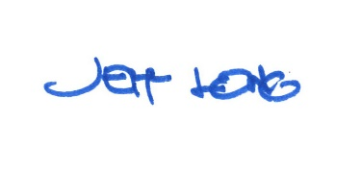

By:

Date of Meeting: February 26, 2018 Title: Historic Officer

